Operation
This chapter provides personnel instructions on carrying out operating modes.

  - Safety instructions
DANGER!
Danger as a result of starting a machine that is not ready for operation!
Serious injury to operating and maintenance personnel and/or considerable property damage could result if the machine is insufficiently or incorrectly prepared.
There is a risk of injury if the safety equipment is inop‐ erable or has been rendered inoperable.
– All criteria for making the machine operational must be met before switching on the machine.
See the chapter entitled “Operation”, section “Pre‐ paring the machine for operation”
WARNING!
Ignoring safety instructions
Risk of injury if safety instructions are ignored. This could result in death or serious injury.
– Safety instructions must be complied with, see chapter “Safety”.

  - Safety equipment
    - Emergency stop switch


Figure 65: Emergency stop switch

An emergency stop switch is fitted on the operator console of the machine. Pressing the emergency stop switch immediately switches all the drives off.
If a hazardous situation arises, personnel must press the emergency stop switch immediately to shut down the machine.

Pressing the emergency stop switch

NOTICE!
Emergency stop switch
Damage to property as a result of misusing the emer‐ gency stop switches. Emergency Stop switches are safety devices that may only be used in dangerous situations.
Any misuse of the emergency stop switches may result in damage to the machine or to items or materials in the surrounding area.
– Do not use emergency stop switches for normal machine switch-off.

Personnel:  Operating personnel Requirement:
      - A hazardous situation has occurred.

- Press the emergency stop switch.
  - The drive of the machine stops.
The touch screen shows the "Emergency stop switch acti‐ vated" fault message.
The corresponding light on the signal light lights up.
WARNING!
Residual energy when the machine is switched off
There is a risk of injury after switching off the machine from the inertial of moving parts and other residual energy.
This could result in death or serious injury.
Components are not always able to return to their ultimate positions and retain residual energy (potential energy) when malfunctions occur. During fault correction, components may move in an uncontrolled fashion to decrease their residual energy.
- After pressing the emergency stop switch, bear in mind that moving parts may still take some time to stop.
- Make sure the machine is secured and de- energized before working on it.
- Take care of injured persons at the installation site in accord‐ ance with first aid regulations.
- Rectify the hazardous situation; see chapter “Faults”.

Checking the machine
Personnel:  Operating personnel
Check the following components.
Feed conveyor/conveyor belt
- Stand products that have fallen over back up.
- Remove damaged products. Application head
- Check the status of the knife. Carrying handle adhesive tape
- Check the flow, tension and cleanliness.
- Check that the tail shaft rolls are clean.

Switching the machine on again after an emergency stop
WARNING!
Improper unlocking of the emergency stop switch
Danger when releasing the emergency stop switch if the emergency situation has not been resolved.
This could result in death or serious injury.
- Determine why the emergency stop switch was actuated.
- Remedy the emergency situation.
- Before unlocking and restarting the machine, ensure that there is no one in the hazardous area.
Personnel:  Operating personnel Requirement:
- There is no longer a hazardous situation.
- Rectify the reason for activation of the emergency stop switch.
- Ensure that no personnel are in the hazardous areas.
- Turn the emergency stop switch to the left or pull it until it disen‐ gages.
  - The machine can be switched on again.
- Check the machine. See below.
- Set the [Operation ON/OFF] key switch to [OFF] and then back to [ON].
  - The status display lights up.
- Press the [Fault reset] button.

- Press the [Start] button.

    - Safety doors
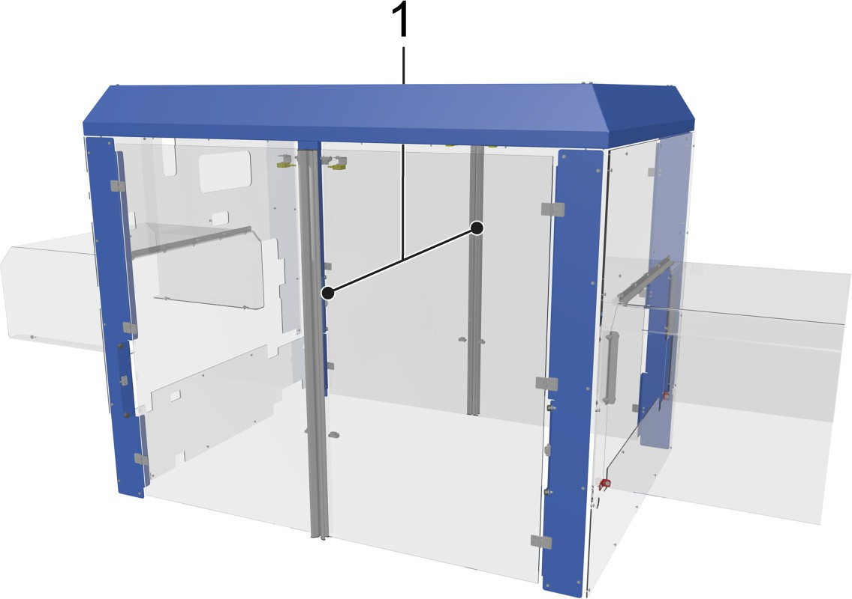

Figure 66: Housing
1 Safety doors
Transparent safety doors on both sides of the machine prevent anyone from reaching into the machine during operation and enable easy access to the interior of the machine. This is necessary for eliminating production malfunctions and for servicing, maintenance and repair work.
An open safety door has several consequences:
      - A corresponding fault message appears on the control panel.
      - The corresponding section of the signal lamp lights up.
      - Machine not starting.

Opening the safety doors
- Press the [Stop] button.
- Wait for a moment until the machine has stopped.
- Open the safety doors outwards using the handle.

Opening the safety doors during operation stops the machine immedi‐ ately.

NOTICE!
Do not deliberately open the safety doors during oper‐ ation. Do not use the safety doors as a means of stop‐ ping the machine.

Closing the safety doors
- Close all safety doors.
- Press the [Fault reset] button.
  - The corresponding section of the signal lamp goes out and the fault message on the operator console disappears.
- Set the [Operation On/Off] key switch to [On].
  - The status display lights up.

Repair switch
A repair switch disconnects individual machine components from the power supply. The repair switch can be secured with a padlock to prevent unauthorized persons from switching it on.
The repair switch can be toggled between the following positions:
      - 0: The components are disconnected from the power supply.
      - I: The components are supplied with power.
The repair switches separate the following components from the power supply:
      - Feed conveyor
      - Conveyor belt

  - Signaling equipment
    - Signal lamp


Figure 67: Signal lamp

The lamps in the signal lamp indicate various operating statuses of the machine.
The signal lamp is located above the control panel or is installed on top of the machine frame.

Lamp color | Lamp status
Lamp color | Permanently illuminated | Flashes
Red | Emergency stop activated | Safety device open
Yellow | Material defect (machine is in operation) | Material defect (machine in standby)
White | Machine in operation | Automatic restart (standby)
Green | Power ON | Service ON
Blue | Fault present, operator action required | Fault ready to be reset

  - Operating controls
    - Switch cabinet operating controls
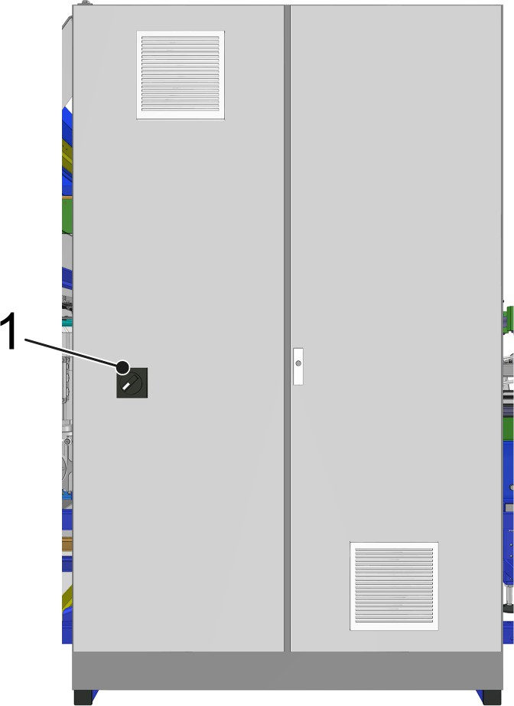

Figure 68: Switch cabinet
1 Main switch

Switch | Action | Function
Main switch | ON | Switches on the power supply to the machine.
Main switch | OFF | Switches off the power supply to the machine.
When the system is switched off, a padlock can be used to secure the main switch against accidental restarting.

    - Mandrel clamp switch
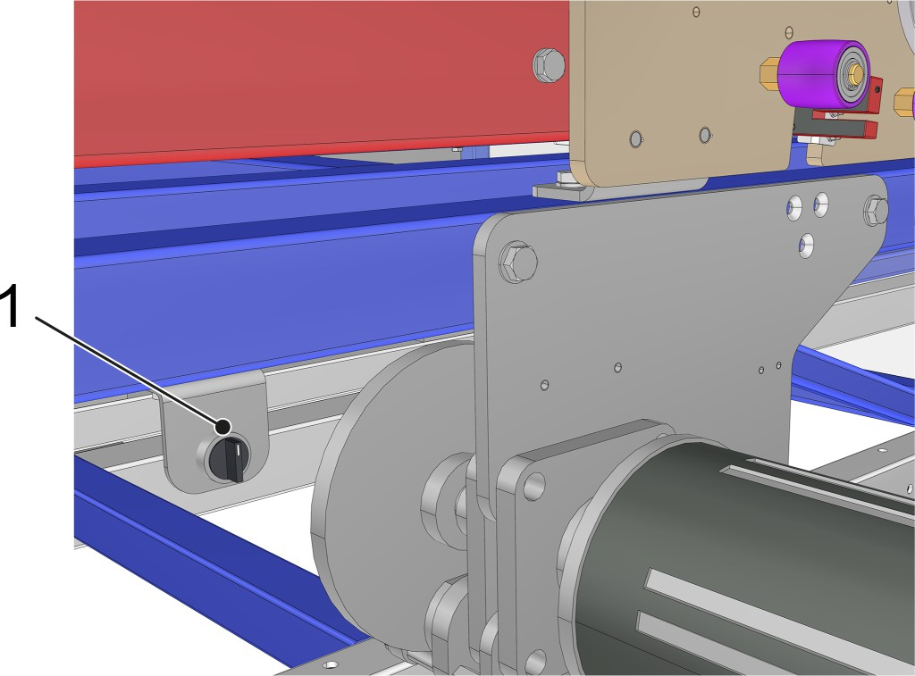

Figure 69
1 Mandrel clamp switch
The mandrel clamp switches are each located in the immediate vicinity of the corresponding spool-holding mandrels. The mandrel clamp switch drives the sleeves of the spool-holding mandrel in or out. The sleeves ensure that the carrying handle spools are fixed on the spool-holding mandrels.

    - Manual control unit
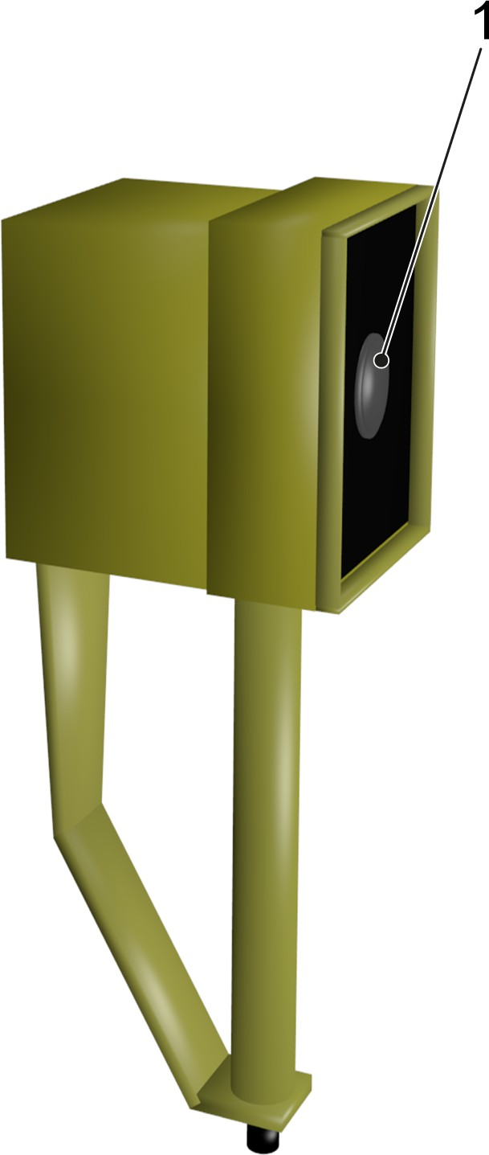

Figure 70: Manual control unit
1 [Jog mode] button
The manual control unit enables the machine to be operated in jog mode and to be started or stopped in any position. In jog mode, the machine moves at jogging speed.
Jog mode is only possible if all moving separating safety devices on the machine are closed. Jog mode stops immediately if a moving separating safety device is opened.
The socket for the manual control unit connector is located on the machine frame or on the operator console.

Run the machine in jog mode
Personnel:  Operating personnel

- Activate “Jog mode”.
See chapter “Operation”, section “Production” > “Jog Mode”.
- Press and hold the[Jog mode] button on the manual control unit.
  - The machine runs at jog speed for as long as the button remains pressed.

- Release the [Jogging mode] button on the manual control unit.
  - The machine stops as soon as the button is released.

    - Shut-off valve on the compressed air maintenance unit
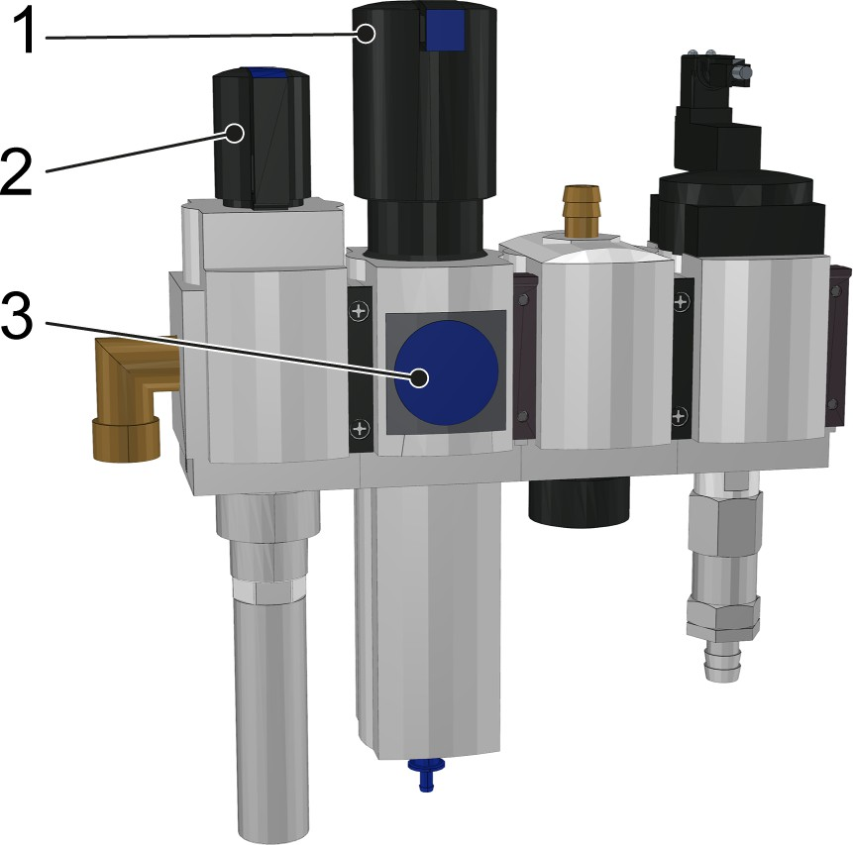

Figure 71: Compressed air maintenance unit (example)
- Pressure controller
- Shut-off valve
- Pressure gauge

The shut-off valve opens and closes the compressed air supply to the machine.
Position of shut-off valve
- Crosswise to the flow direction: compressed air supply closed
- Parallel to the flow direction: compressed air supply open
The pressure can be adjusted in the machine using the pressure controller and pressure gauge.

Preparing for operation
Personnel:  Operating personnel
- Open the shut-off valve on the compressed air maintenance unit.
- Check the pressure on the pressure gauge.
- Set the pressure using the pressure controller.
  - The compressed air supply of the machine is ready.

- Switch on the main switch at the switch cabinet operating control
  - The power supply is ready.

The machine is ready for operation.

Carrying handle adhesive tape
During operation, the carrying handle adhesive tape is pulled by a carrying handle spool for each lane of the machine. A dancer ensures that there is a uniform tension.
The machine recognizes the end of a carrying handle spool by a laminated end mark and stops automatically.

CAUTION!
Heavy carrying-handle spools
Loading the machine with carrying-handle spools may involve particular physical strain.
This could result in slight or minor injury.
– When loading the machine, avoid any physical strain.

Changing carrying handle spools
- Cut the carrying handle adhesive tape before the end mark.
- Stick the end of the threaded carrying handle adhesive tape to the machine, thus temporarily fastening it.
- Activate the mandrel clamp switch.
  - The sleeves of the spool-holding mandrels retract.
NOTICE!
In the absence of compressed air, the man‐ drel clamp and the brake of the spool-holding mandrels will not work.
Establish compressed air supply.
- Remove used carrying handle spool.
- Slide on new carrying handle spool.
- Stick the threaded end of the carrying handle adhesive tape to the start of the new carrying handle spool.

- If necessary, rotate the carrying handle spool against the direc‐ tion of motion and thus tighten the carrying handle adhesive tape.
- Activate the mandrel clamp switch again.
  - The sleeves of the spool-holding mandrels extend and fix the carrying handle spool in position.

When changing format, after maintenance, repair, or cleaning work, and as a result of an emergency stop, it may be necessary to thread the carrying handle adhesive tape into the machine again.

CAUTION!
Sharp knife on the application head Risk of puncture wounds or cuts
This could result in slight or minor injury.
– Wear cut-resistant protective gloves when per‐ forming any work on the application head.

Threading the carrying handle adhesive tape
- Activate the mandrel clamp switch.
  - The sleeves of the spool-holding mandrels retract.
- Slide on the new carrying handle spool.
- Pull the start of the carrying handle adhesive tape from the carrying handle spool and, using the diagram numbering, thread the tape into the machine.
NOTICE!
The carrying handle adhesive tape must lie smoothly and without any folds on the tail shaft rolls. The carrying handle adhesive tape must not hang down between the tail shaft rolls.
If the tail shaft rolls are marked with numbering in a border, the adhesive surface of the carrying
handle adhesive tape must be facing the tail shaft roll.
Check that the carrying handle adhesive tape is flowing smoothly and that it is taut.
- Position the end of the carrying handle adhesive tape in front of the application head pressure roller.
- If necessary, rotate the carrying handle spool against the direc‐ tion of motion and thus tighten the carrying handle adhesive tape.

- Activate the mandrel clamp switch again.
  - The sleeves of the spool-holding mandrels extend and fix the carrying handle spool in position.

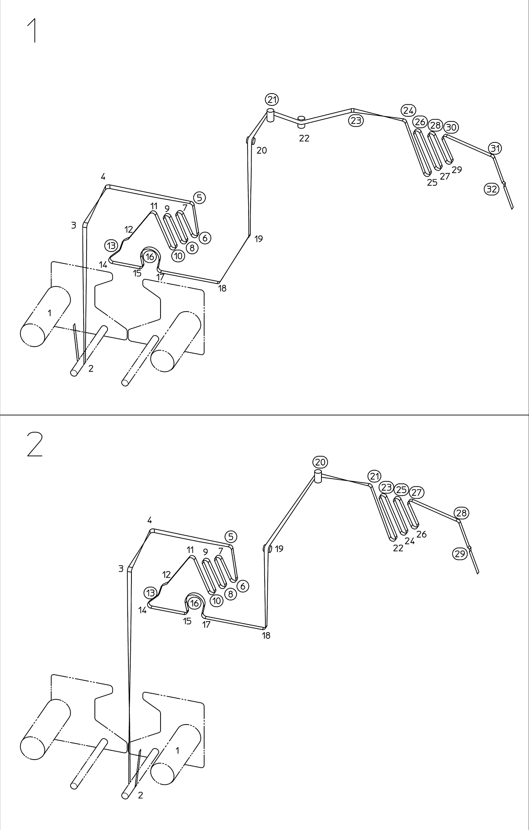

Figure 72: Diagram illustration

Laminating device
There is a colored lane through the laminating device for each spool- holding mandrel.
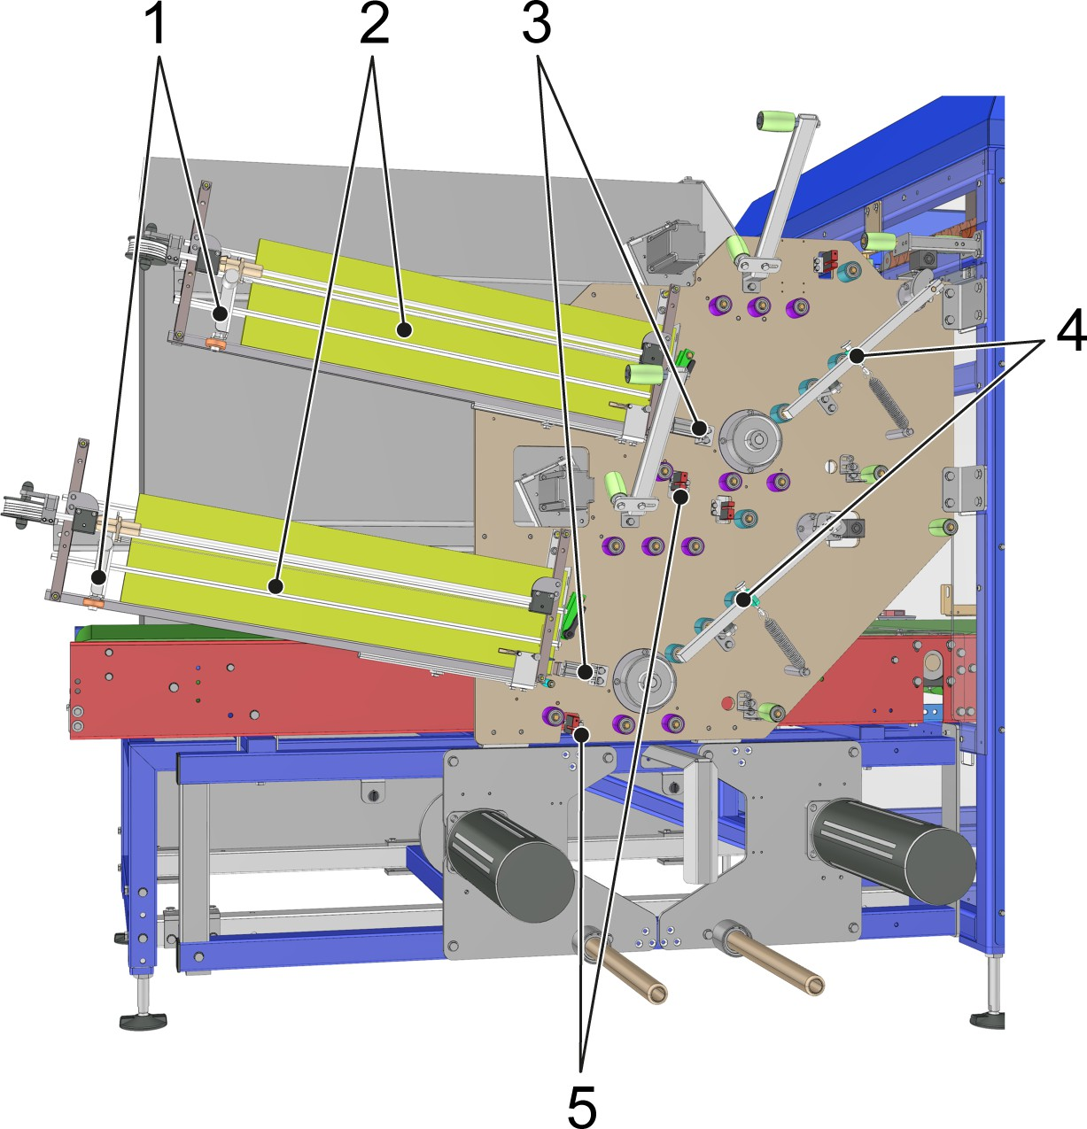

Figure 73: Laminating device
- Label slide
- Label magazine
- Pneumatic cylinder
- Dancer
- Eye mark detection
Here, with the help of an eye mark detection and a pneumatic cyl‐ inder, the labels are precisely positioned and laminated as the car‐ rying handle adhesive tape is fed through the laminating device. Each separate label magazine has a stock of labels ready for this. An addi‐ tional dancer ensures that the tension of the carrying handle adhesive tape is correct.

WARNING!
Laminating device pressing cylinder
Risk of injury from the open pneumatic cylinder for pressing the labels in the laminating device. Danger of crushing.
This could result in serious injury.
- Do not reach into the laminating device while it is in operation.
- Secure and deenergize the laminating device before performing any work on the machine.
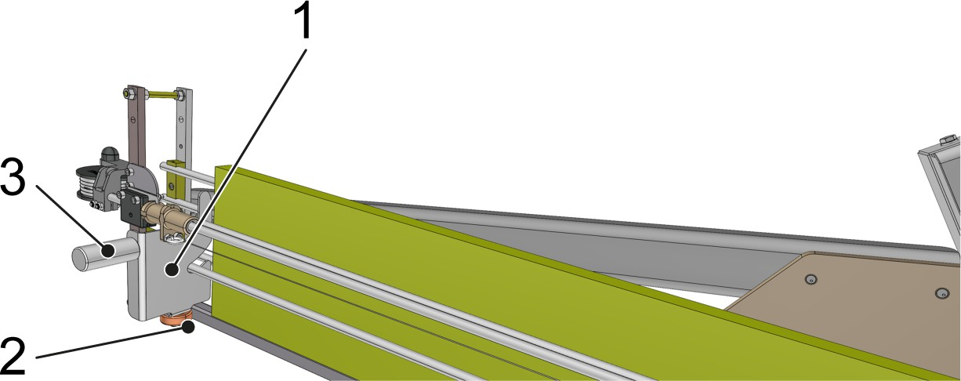

Figure 74: Label magazine
- Label slide
- Guide roller
- Carrying handle
A proximity switch detects the position of the guide roller. The position of the guide roller indicates how full the label magazine is. If the minimum filling level is not met, the control panel displays a corre‐ sponding message and the machine stops automatically.


Wear hand protection

Inserting labels
- Open the packet of labels and loosen the label stack.
- Insert the labels with the writing facing the stopper plate in the label magazine
  - The label slide pushes the labels evenly against the stopper plate

Production can be continued.

In the event that the machine is being operated with pre-laminated carrying handle adhesive tape, the label slide must be locked so that the label magazine can remain empty.

Locking the label slide
Using the carrying handle, pull the label slide back to the end stop.
  - The lock engages in the locking bolts.

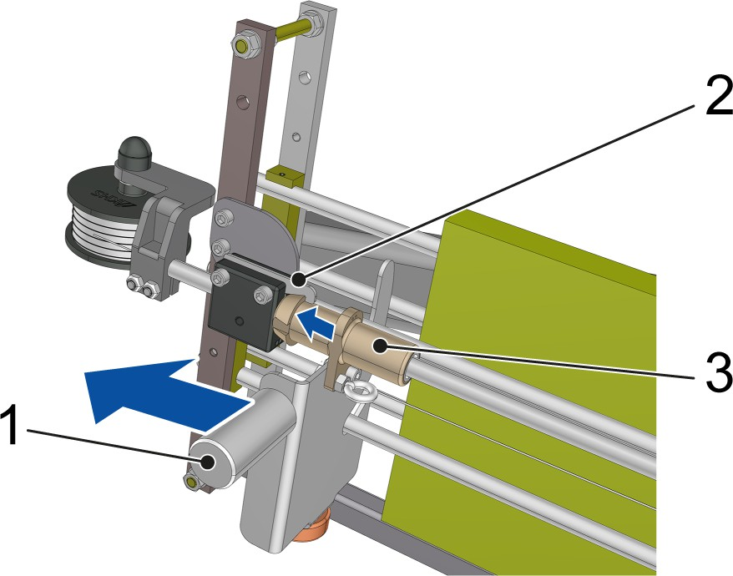

Figure 75: Locking the label slide
- Handle
- Lock
- Locking bolts

Unlocking the label slide
- Using the carrying handle, swivel the label slide 90° upwards.
  - The locking bolts are released.
- Using the carrying handle, push the label slide forwards across the guide rail

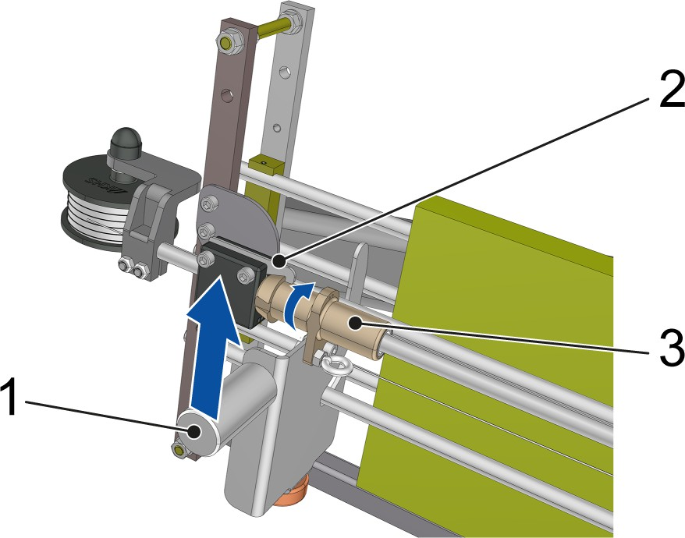

Figure 76: Unlocking the label slide
- Handle
- Lock
- Locking bolts

Production
This chapter provides personnel with instructions for carrying out pro‐ duction tasks.

Safety instructions
WARNING!
Ignoring safety instructions
Risk of injury if safety instructions are ignored. This could result in death or serious injury.
– Safety instructions must be complied with, see chapter “Safety”.

    - Requirements
      - The machine is ready for operation; see the chapter entitled

“Operation”, section “Preparing the machine for operation”.
      - Remove all foreign objects (tools, cloths etc.) from the machine.
      - No personnel are in the hazardous area of the machine.

Preparation
Check the following items and correct any defects each time before starting production:
- Check type selection:
  - Type to be fed selected on screen.
  - Mechanical type settings correctly set.
- Check the feed conveyor:
  - No product has fallen over.
- Check the carrying handle adhesive tape:
  - Stock is sufficient.
  - Flow and tension are correct.
- Check the label magazine:
  - Stock is sufficient.

Starting
Personnel:  Operating personnel
Prerequisite: Machine is ready for operation; see section “Preparing for operation”.
- Set the [Operation On/Off] key switch to the [On] position.
  - The status display lights up.
- In the “Program selection” view, press the “Production” button.
  - The machine control system accepts the production pro‐ gram.
- Press the [Start] illuminated push button.
- Turn the [Collating system disabled/enabled] selector switch to the [enabled] position.
  - The machine now runs at the speed set by the machine control system.

Monitoring
Personnel:  Operating personnel
It is the operator's task to monitor the machine during production and to ensure that it is kept in operation.
      - He has to respond to hazardous situations and avert them.
      - He has to resolve errors and faults during operation.
      - In particular, he has to ensure that the machine is supplied with carrying handle adhesive tape.

Stopping
Personnel:  Operating personnel
- Turn the [Collating system disabled/enabled] selector switch to the [disabled] position.
- Wait until there are no more packs in the machine.
- Press the [Stop] push button.
  - The machine stops at a defined position.
- Set the [Operation on/off] key switch to the [Off] position.
  - The status display goes out.

Changing operating mode
Switching from automatic mode to jogging mode Personnel:  Operating personnel
      - The machine is ready for operation.
      - All safety doors are closed.
- In the “Program selection” view, press the “Setup” or “Maintenance” button, depending on which program is to be executed.
Jog mode is only available in the “Setup” and “Maintenance”
programs.
- Connect the manual control unit to the socket on the machine frame.
Jog mode is only available with the manual control unit con‐ nected.
- Press the [Start] illuminated pushbutton.
  - Jog mode is available.

Jog mode
Personnel:  Operating personnel
Press and hold the[Jog mode] button on the manual control unit.
  - The machine runs at jog speed for as long as the button remains pressed.

Personnel:  Operating personnel
Release the [Jogging mode] button on the manual control unit.
  - The machine stops as soon as the button is released.

Jog mode allows the machine to be moved gradually in manual mode.

Switching from jog mode to automatic mode Personnel:  Operating personnel
- The machine is ready for operation.
- All safety doors are closed.
- Disconnect the manual control unit from the socket on the machine frame.
- In the “Program selection” view, press the “Production” button.
  - The machine control system accepts the production pro‐ gram.
- Press the [Start] illuminated push button.
  - The machine starts in automatic mode.

    - Switching off the machine Requirement: the machine has been stopped.
- Switch off the main switch on the switch cabinet operating con‐
trol.
  - The power supply for the machine is interrupted.
- Close the shut-off valve on the compressed air maintenance unit.
  - The supply of compressed air to the machine is interrupted.

The machine is switched off.

Setup
This chapter provides personnel with instructions on setting up the machine for the production of various goods.

    - Safety instructions
CAUTION!
Concussions and lacerations
Danger of impact and cutting injuries from protruding components.
This may result in slight or minor injury.
– Take particular care around these components.

    - General information

The factory settings for the individual types are only reference values for default settings. The final set‐ tings are determined during commissioning on-site and under actual production conditions.
NOTICE!
Risk of damage from using non-original spare parts and accessories!
Original parts and accessories have been designed especially for the machine.
Installing and using non-original spare parts and non- original accessories may affect the safety of the machine and cause machine damage.
- Spare parts and accessories not supplied by KHS are not tested and not approved
- Use only original parts and original accessories supplied by KHS.

    - Basic procedure Setting up the machine
Personnel:  Operating personnel
Requirement:
      - An alternative type is designated for machine production.
- Press the [Stop] button.
- Close the shut-off valve on the compressed air maintenance unit.

- In the “Program selection” view, press the “Changeover (Type selection)” button.
  - The “Type selection” screen opens.
- Press the button next to the required type.
  - The desired type is activated.
- Open a safety door and leave this open throughout the entire setup process.
- Adjust all adjustment points on the machine to the type- dependent setting values.
See chapter “Adjustment points”
- Remove all tools and loose conversion parts from the machine.
- Check the settings.
- Open the shut-off valve on the compressed air maintenance unit and check the pressure on the pressure gauge.
- Start the machine.

Adjustment points
All adjustment points on the machine have been provided with an identifier that consists either of a combination of numbers, or of num‐ bers and letters.
The first part of the identifier comprises the numbers of the individual adjustment points.

1 | Product width lateral guide, lane 1
2 | Product width application head, lane 1
3 | Product width lateral guide, middle lane 1
4 | Product height bow creation, lane 1
5 | Product width lateral guide, middle lane 2
6 | Product width application head, lane 2
7 | Product width lateral guide, lane 2
8 | Product height bow creation, lane 2
9 | Outlet product width roller guide
10 | Product width roller guide, lane 1
11 | Inlet product width roller guide
12 | Inlet product width roller guide

The second part of the identifier indicates on which side of the machine the adjustment point is located.

A, B | Operator side
C, D | Rear side
The adjustment list contains the settings for all the adjustment points for every type. The settings can easily be matched to their adjustment points using the identifier.
It is possible that after long periods of operation, individual values may need to be adapted to the machine or that new values need to be added, in particular, when setting up new types. In this case, the new values need to be entered into the adjustment list.

Inlet product width roller guide
The roller guide at the inlet of the machine must be set according to product type.
For the type-specific measurements, see the list of adjustment points. The following adjustment points are available:
      - 11A, 11B, 11C, 11D
      - 12A, 12B, 12C, 12D

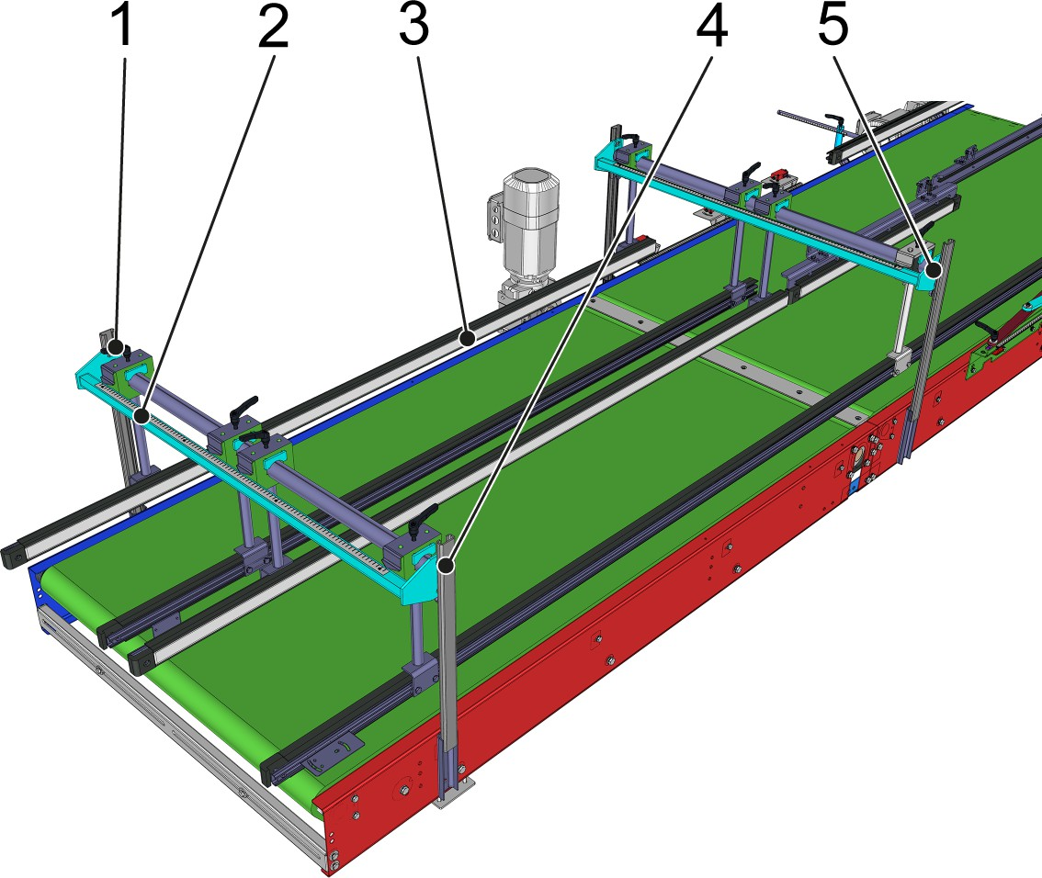

Figure 77: Inlet roller guide adjustment
- Clamping lever
- Measuring tape
- Guide rail
- Adjustment points 12A, 12B, 12C, 12D
- Adjustment points 11A, 11B, 11C, 11D
- Release the clamping lever.
- Set guide rails to the type-specific width using the material line.
- Tighten the clamping lever.

Product width lateral guide
The lateral guide must be set according to product type.
The type-specific measurements can be found in the adjustment list. The following adjustment points must be set in sequence:

1 | Product width lateral guide, lane 1
3 | Product width lateral guide, middle lane 1
5 | Product width lateral guide, middle lane 2
7 | Product width lateral guide, lane 2

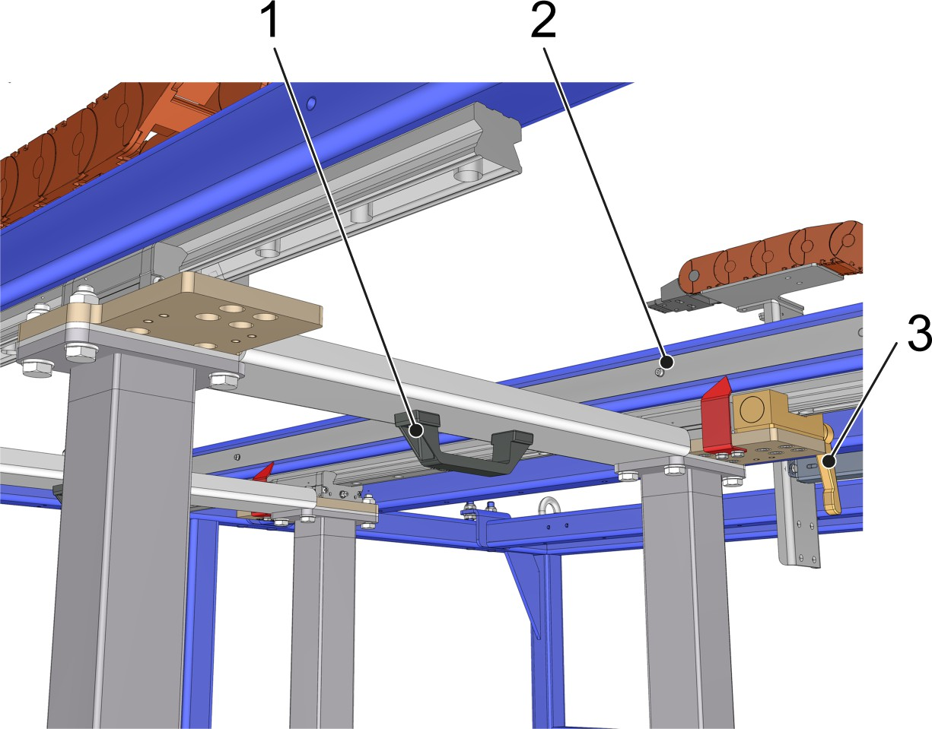

Figure 78: Lateral guide adjustment
- Handle
- Measuring tape
- Clamping lever
- Release the clamping lever.
- Set the lateral guide to the type-specific width using the carrying handle and based on the material line.
- Tighten the clamping lever.

Product width application head
The application head must be set according to product type. For the type-specific measurements, see the adjustment list. The following adjustment points must be set in sequence:

2 | Product width application head, lane 1
6 | Product width application head, lane 2

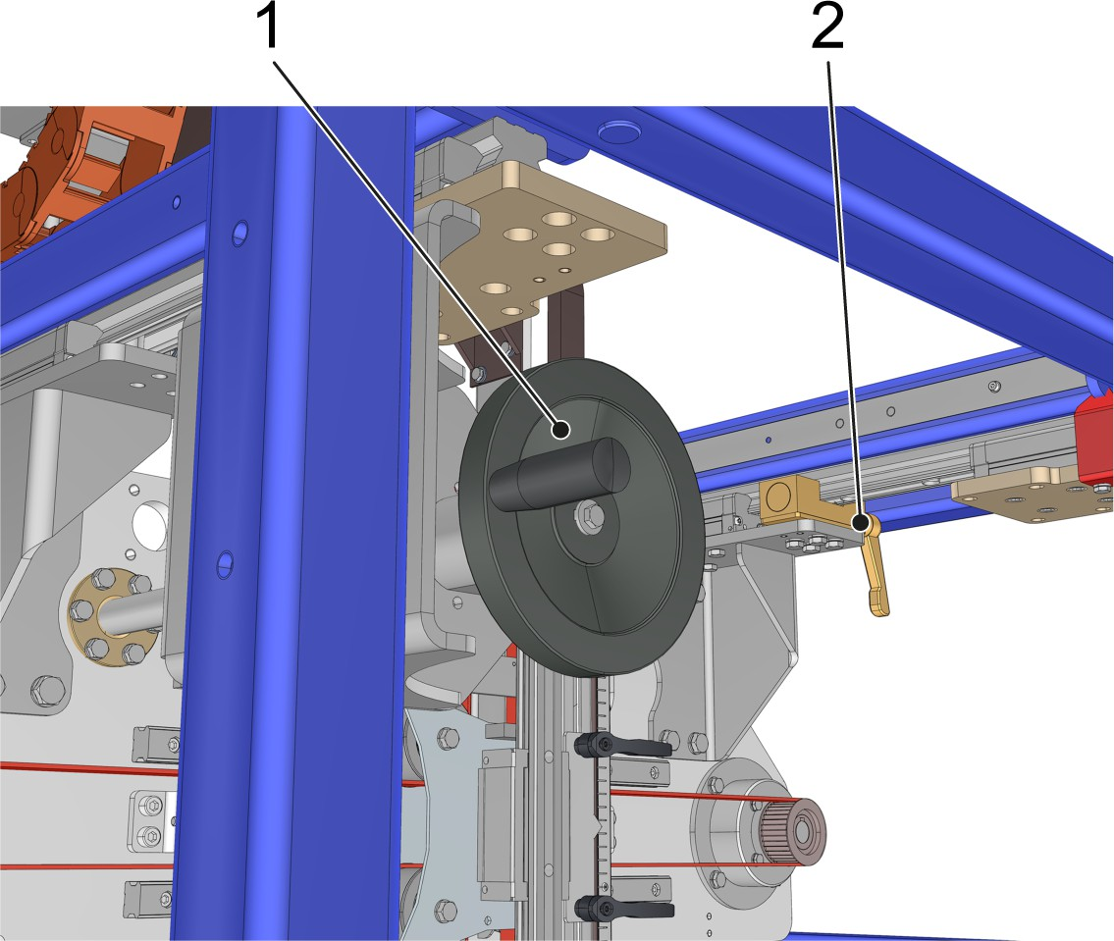

Figure 79: Application head adjustment
- Handwheel
- Clamping lever
- Release the clamping lever.
- Turn the handwheel until the type-specific number is displayed in the position indicator behind the handwheel.
- Tighten the clamping lever.

Product height bow creation
The bow creation must be set according to product type.
For the type-specific measurements, see the adjustment list. The following adjustment points must be set in sequence:

4 | Product height bow creation, lane 1
8 | Product height bow creation, lane 2

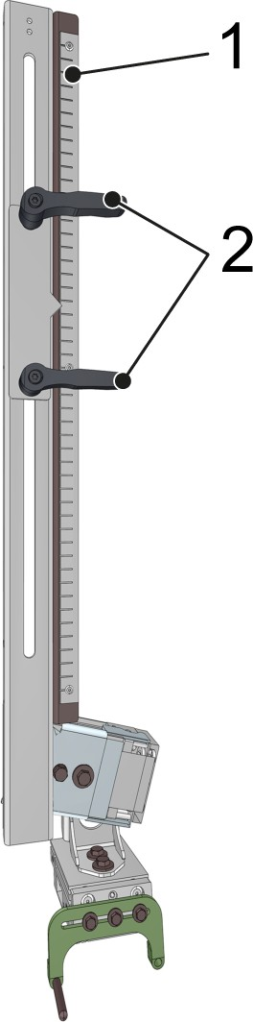

Figure 80: Bow creation adjustment
- Measuring tape
- Clamping lever
- Release the clamping lever.
- Move the bow creation to the type-specific position based on the material line.
- Tighten the clamping lever.

Product width roller guide, lane 1
The roller guide positioned before the application area of lane 1 must be set according to product type.
For the type-specific measurements, see the list of adjustment points. The following adjustment points are available:
      - 10

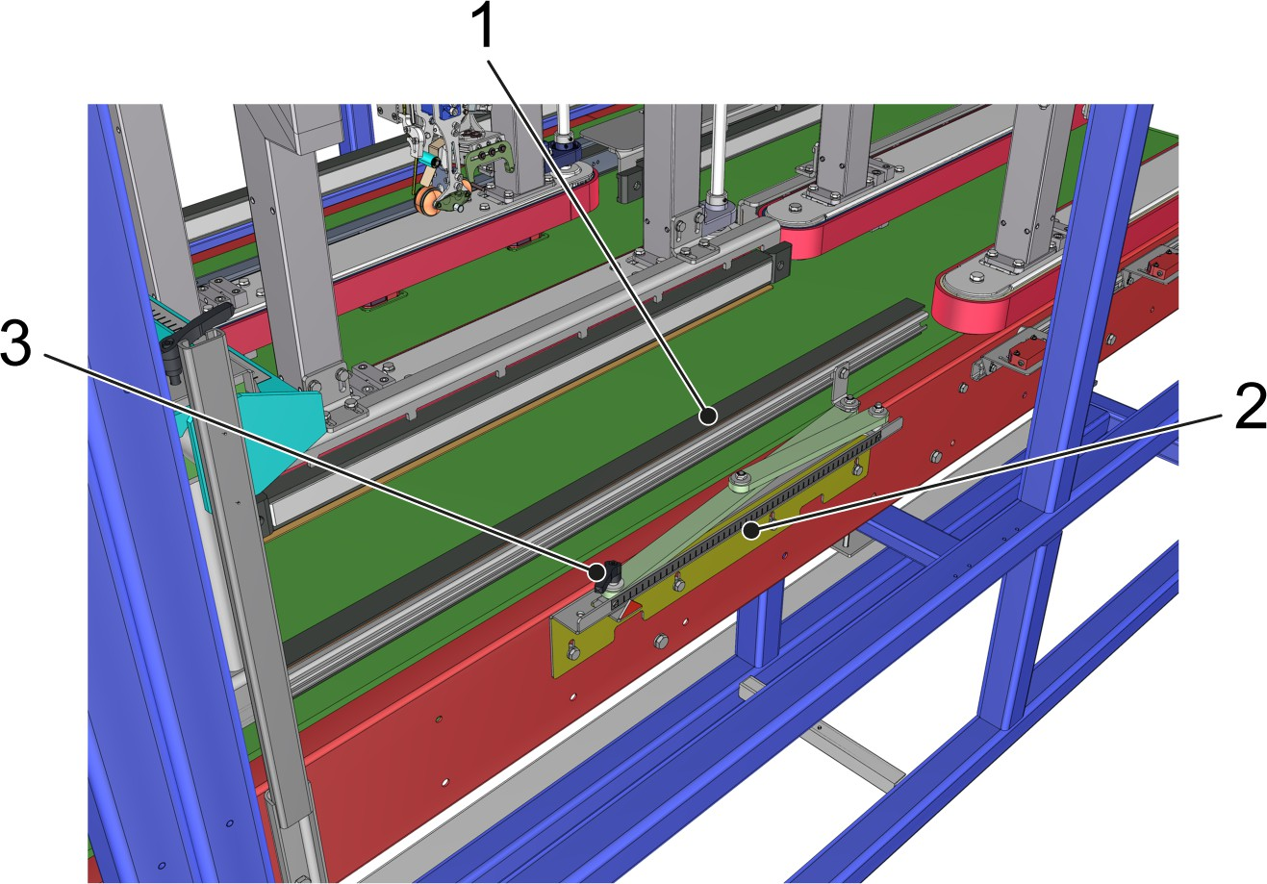

Figure 81: Roller guide adjustment, lane 1
- Guide rail
- Measuring tape
- Clamping lever
- Release the clamping lever.
- Set guide rails to the type-specific width using the material line.
- Tighten the clamping lever.

Outlet product width roller guide
The roller guide at the outlet must be set according to product type. For the type-specific measurements, see the list of adjustment points. The following adjustment points are available:
      - 9

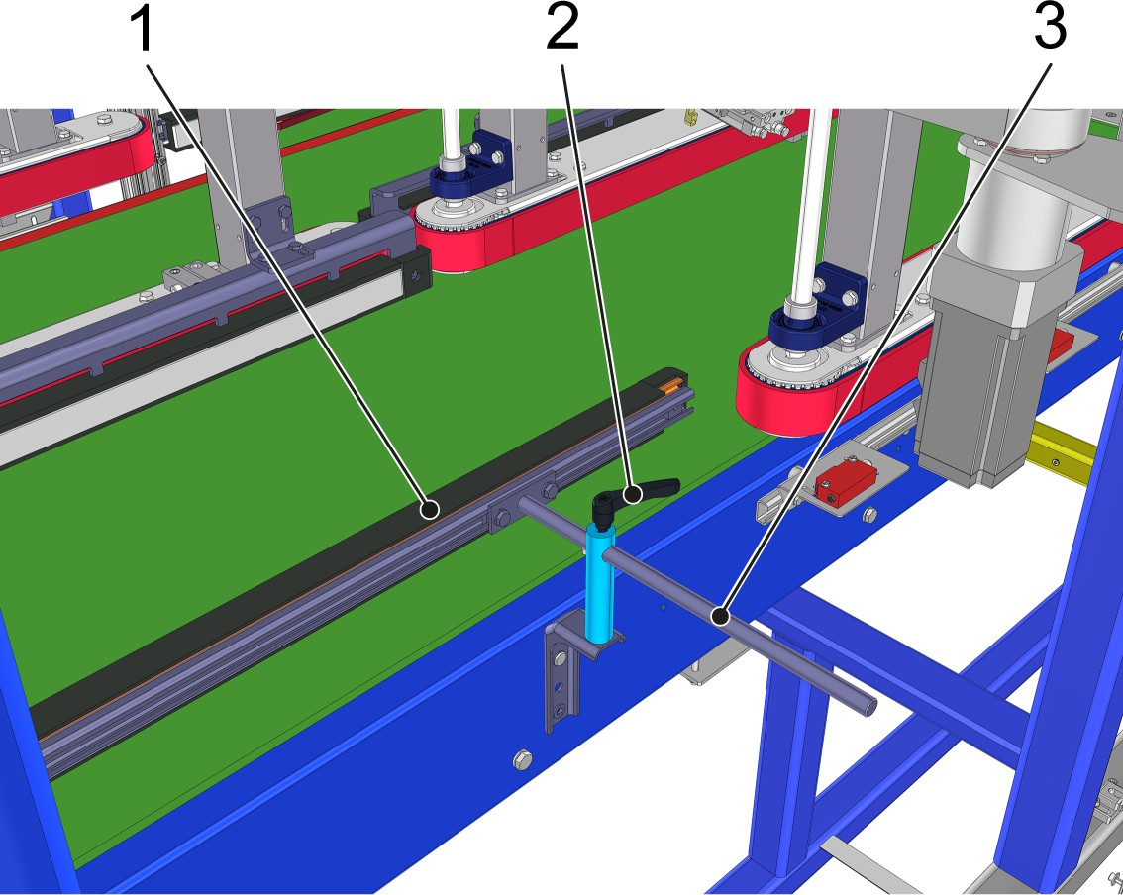

Figure 82: Outlet roller guide adjustment
- Guide rail
- Clamping lever
- Measuring tape
- Release the clamping lever.
- Move the guide rail to the type-specific position based on the material line.
- Tighten the clamping lever.

This page is left blank for editorial reasons.

